End of Semester Project Status Report

*ProtoControl*

Team Members:

[Kelly Mae Allen](mailto:kmallen5@ncsu.edu)

William Wood

Abisha Fenn

[Nida Kosedagi](mailto:nkoseda@ncsu.edu)

[Parker Sexton](mailto:pbsexton@ncsu.edu)

Sponsoring Company:

Parker Sexton & Co.

Mentors:

[Jim Carlson](mailto:jbcarlso@ncsu.edu)

Date: 12/1/23

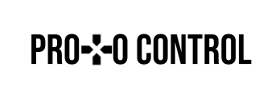

**Project End of Semester Status Report to Sponsors**

**Project Summary**

ProtoControl is a development platform that incorporates hardware and software to help our customers design a user interface. Unlike other user interface devices, we do not require any embedded software to design the interface, and our on board microcontroller is able to interpret information about the intended layout of the capacitive touchscreen and other connected peripherals without having to upload any code.

We aim to be compatible with a variety of user systems that span use case, scale, and component variety in our efforts to revolutionize user interface design.

Right now, we have a working proof of concept prototype that demonstrates almost all of the key functionalities we aim to achieve. Once the user designs their ideal UI layout on our intuitive drag and drop interface, the website is capable of generating an encoded text file which is transferred to our screen via an SD card. Our embedded software is capable of decoding this message and drawing digital components on the screen, based on the contents of the card. The screen and microcontroller are connected with our Custom PCB, which mounts all components as well as provides useful test points and ports for UART and our physical components. These physical components work over the I2C bus to provide tactile user input, and we have a GPIO pin expander IC working to communicate with the microcontroller. The IC allows the user to swap out peripheral components easily which affords them greater flexibility. Lastly, we have an example user system running on an Arduino UNO and have successfully demonstrated two way UART communication to send and receive inputs and outputs.

**Change in Project Scope**

Our team composition has changed to focus more on the integration between the user device and Protocontrol so that we can demonstrate compatibility. We have made this change by refocusing the efforts on enclosure design and power system to the task of integration. This change has allowed us to build the current prototype that showcases all the main aspects of our system together.

**Possible issues during the project**

It will be important for us to use compatibility and ease of use as guiding principles as we continue to make design choices so that our final product is streamlined. It is also important to not get bogged down in the work of integrating one specific system or component and remember the larger picture.

**Support**

The main support we need is just to continue receiving guidance with issues and confusion as they come up.

**Recommendations**

Parker Sexton. Email: [pbsexton@ncsu.edu](mailto:pbsexton@ncsu.edu)

Phone: 9197046108

**General Comments**

**Photos**

**Peripheral Components**

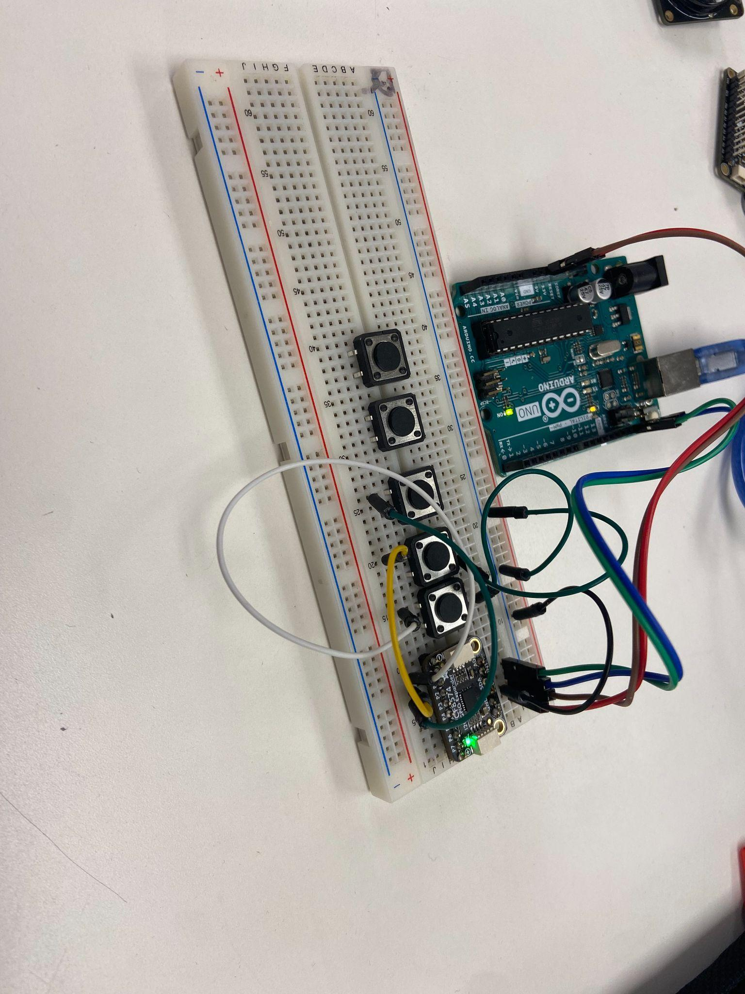

**PCB Design**

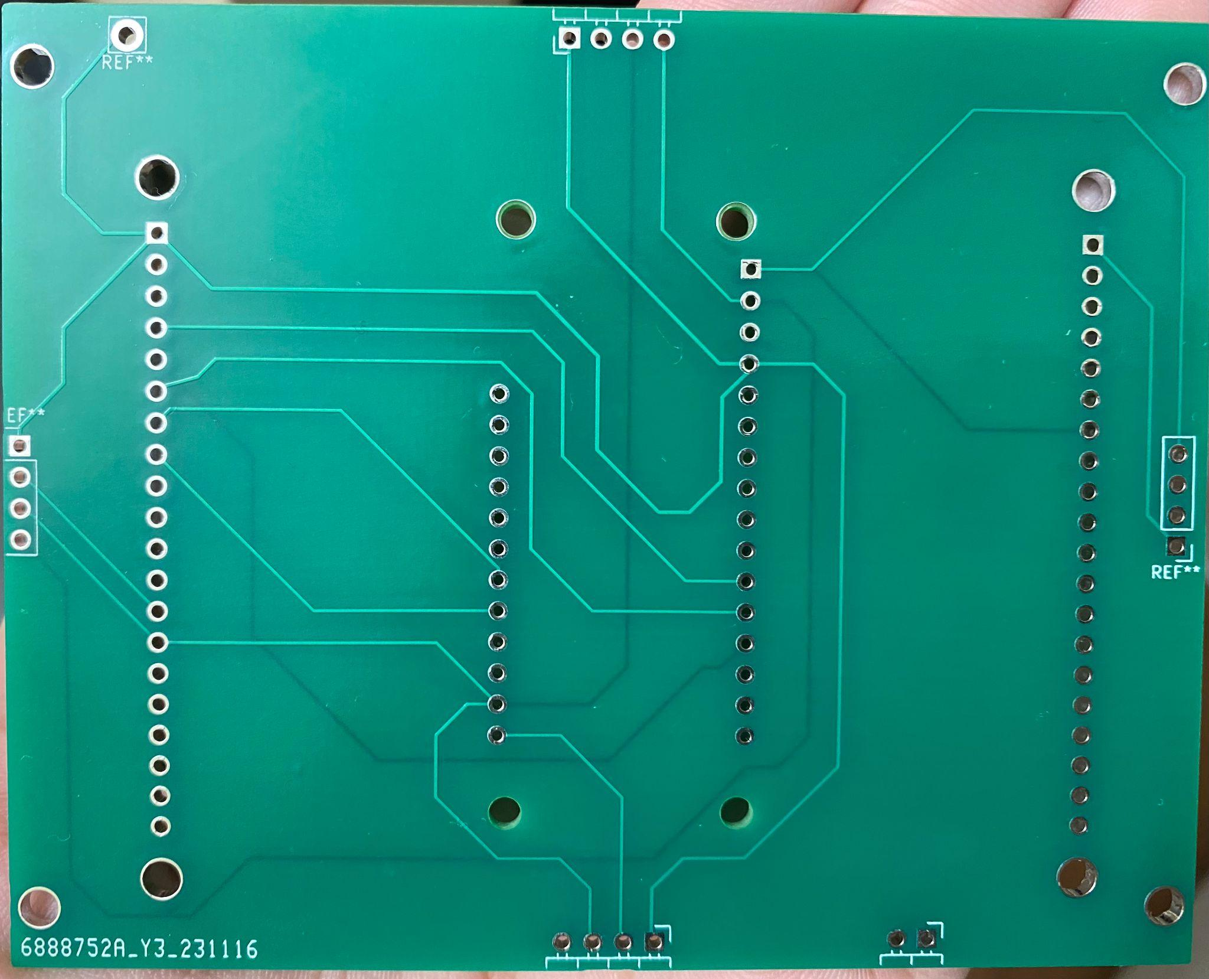

**Full System**

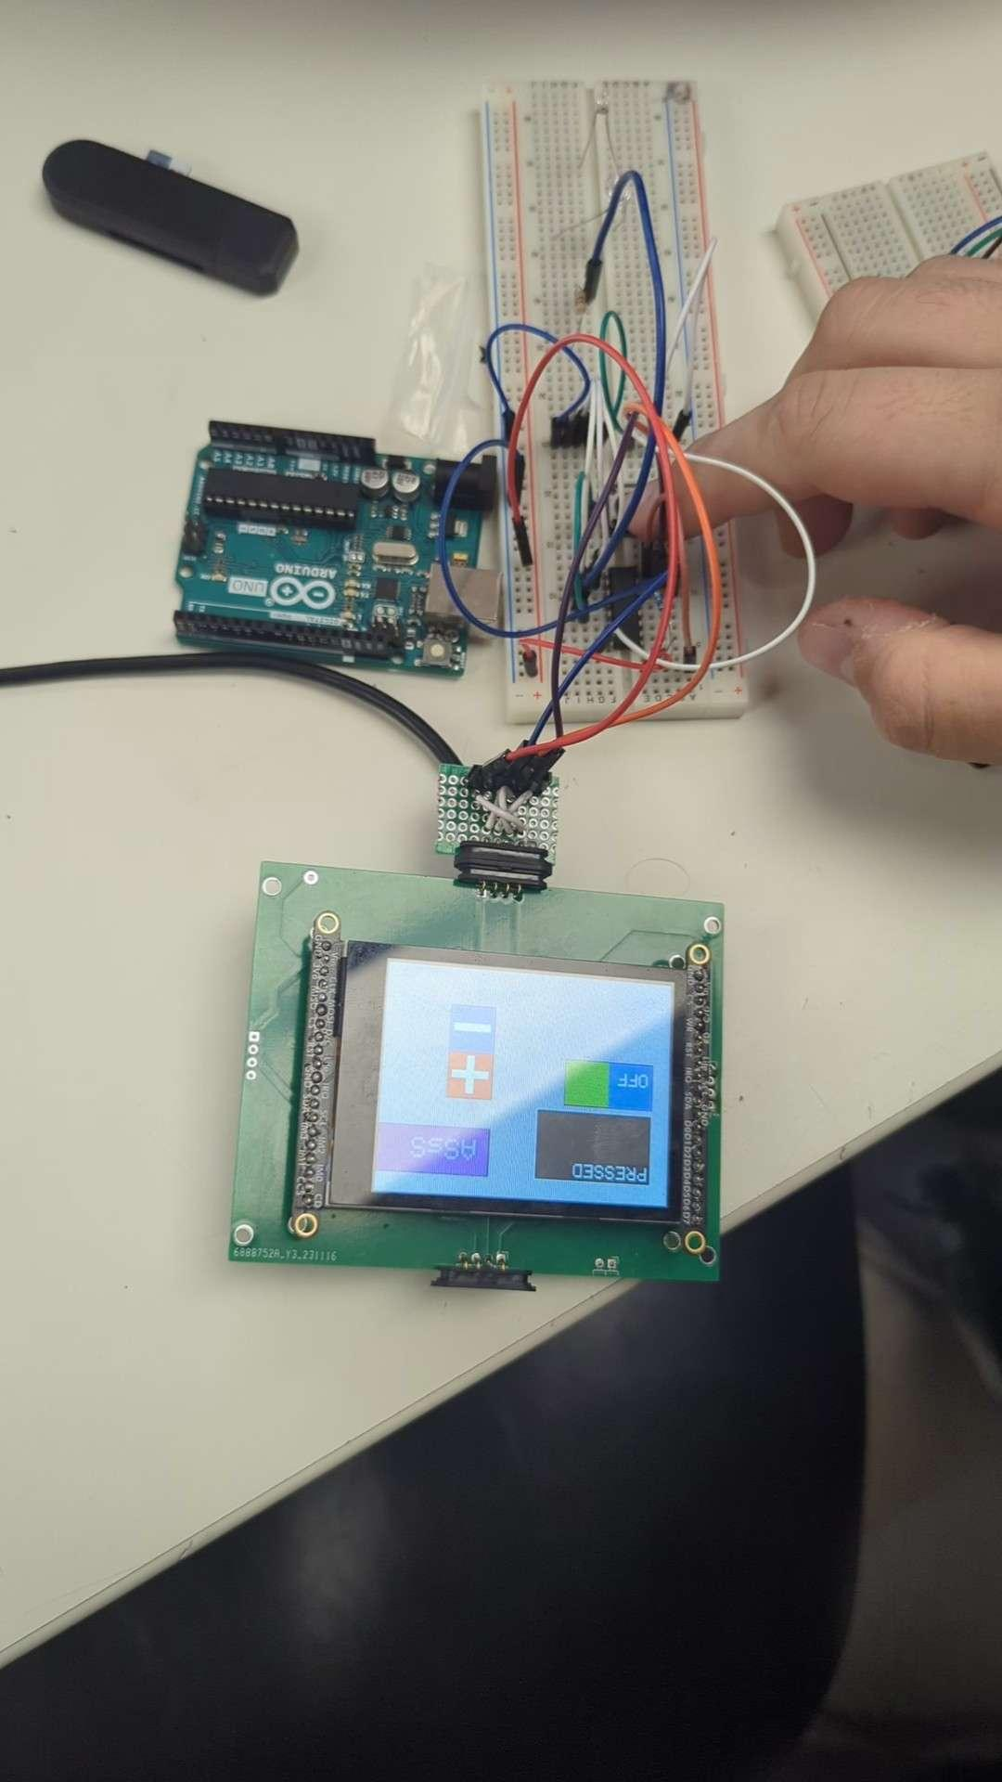

**Website UI**

